6) Find the percentage and the count of each case status on total applications for each year. Create a line graph depicting the pattern of All the cases over the period of time.

LINE GRAPH FOR EACH CASE STATUS

1. CERTIFIED

GRAPH

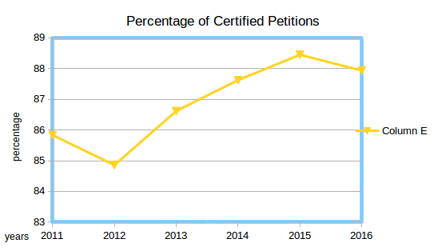

2. CERTIFIED-WITHDRWAN

GRAPH
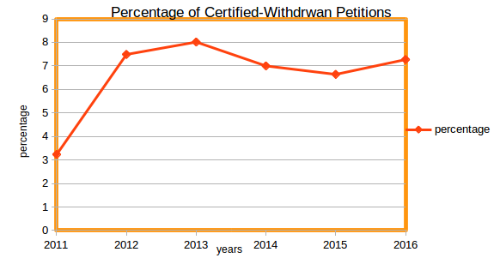

3.WITHDRAWN

GRAPH

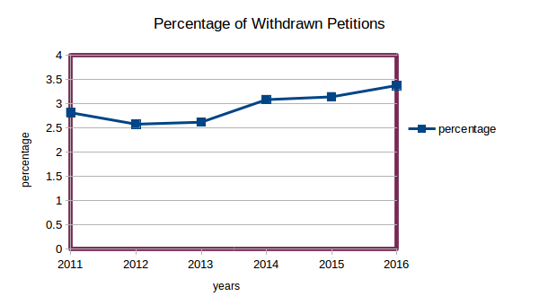

4. DENIED

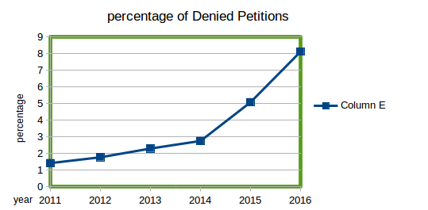
GRAPH

